**Domain names and ICANN**

# **What is a Domain Name?**

A Domain Name is part of a [URL](https://icannwiki.org/URL) and can be typed into a browser to find a particular web site. A domain name is essentially your website’s equivalent of a physical address. In the same way that a GPS needs a street address or a zip-code to provide directions, a web browser needs a domain name to direct you to a website.

When a computer connects to the Internet, it uses a unique [IP Address](https://icannwiki.org/IP_Address); because [IP Addresses](https://icannwiki.org/IP_Address) can be difficult to remember, the [DNS](https://icannwiki.org/DNS) or Domain Name System was put in place to correlate [IP Addresses](https://icannwiki.org/IP_Address) to domain names.

[ICANN](https://icannwiki.org/ICANN) is the ruling body that monitors the domain naming system.

A domain name takes the form of two main elements. For example, the domain name **Facebook.com** consists of the website’s name (Facebook) and the domain name extension (.com). When a company (or a person) purchases a domain name, they are able to specify which server the domain name points to.

## **How Do Domains Work?**

Domain names work by acting as a shortcut to the server that hosts your website.

Without a domain name, anyone who wanted to visit your website would have to enter the full IP address. But the problem is that an IP address is difficult for people to memorize or to include on advertising materials.

In our case, **Hostinger.com** is the domain name. Let’s say it points to the IP address  **100.90.80.70**. The IP address points to a server, but it doesn’t resolve the website if visitors try to use it. That’s because for an IP address to resolve a website, the remote server needs to be using port 80 with a default page (i.e. index.html) stored in its web-apps directory.

As you can see, messing around with server defaults and IP addresses can be both confusing and time-consuming. That’s why the vast majority of website owners opt to utilize a service like **[Hostinger](https://www.hostinger.com/" \t "_blank)** which offers bundled domain names with annual [**web hosting packages**](https://www.hostinger.com/web-hosting).

Domains can also use redirects, which essentially allow you to specify that if people visit your domain, they’re automatically forwarded to another. This can be useful for campaigns and microsites or for forwarding people to dedicated landing pages on your main site. They can also come in useful for avoiding confusion around spellings. For example, if you visit **www.fb.com**, you’ll be forwarded to **www.facebook.com**.

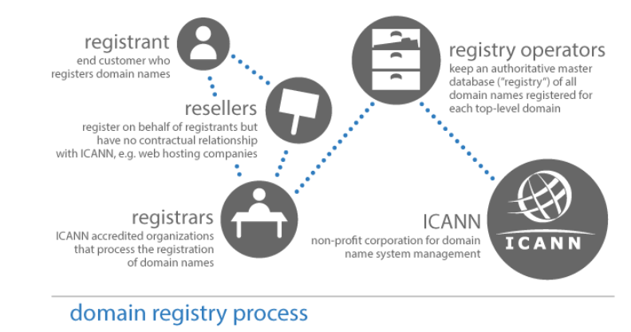

[**Domain name registrations**](https://www.hostinger.com/domain-checker)

[Domain name registrations](https://www.hostinger.com/domain-checker) are overseen by an organization called **ICANN** (Internet Corporation for Assigned Names and Numbers). ICANN specifies which domain name extensions are available and keeps a centralized database of where the domain names point to.

Every website that you visit effectively consists of two main elements: a **domain name** and a **web server**.

1. A web server is a physical machine that hosts the files and the databases that your website is made from and sends them out to people across the internet when they visit your site from their machine.
2. The domain name is what people type in to access your site, and it points the web browser to the server that stores those resources. Without a domain name, people would need to remember the specific IP address of your server — and that is just not going to happen.

**Types of Domain names**

1. [Generic Top-Level Domain Names](https://icannwiki.org/GTLD)  
   These domain name extensions began to appear in the 1980's, and now include: [.com](https://icannwiki.org/.com), [.net](https://icannwiki.org/.net), [.mobi](https://icannwiki.org/.mobi), etc. Anyone can register a domain name under this extension, but these domains have restricted use.
2. [Country Code Top-Level Domain Names](https://icannwiki.org/CcTLD)  
   There are generic top-level extensions at a national level, which based on a code depending on the country, such as: France -.fr, Romania-.ro, United Kingdom-.uk, etc. National entities are responsible with the administration of these specific country codes.
3. [Internationalized Domain Names](https://icannwiki.org/IDN)  
   An IDN is an Internet domain name that uses the latest ICANN protocols and standards to support domain names written in multiple scripts and languages (non-ASCII characters).

**How is Domain name Organized?**

Basically, a domain names consists of an alphanumeric string which is divided into sections, with the most important sections separated by periods. For instance, if we take "icannwiki.org" the most important sections of this domain name are:

* The highest level of the domain name, known as the [Top-Level Domain](https://icannwiki.org/TLD) is found at the far right; in this case it is the ".org" string.
* The [TLD](https://icannwiki.org/TLD) could have subdivisions, but in this case the information immediate to the left is the [Second-Level Domain](https://icannwiki.org/SLD), represented by "icannwiki".

A domain name is organized from right to left, with the specific descriptions in the left part of the domain name while the general descriptors are in the right part. The machine name ([WWW](https://icannwiki.org/index.php?title=WWW&action=edit&redlink=1)) is positioned at the far left. Dots are used in order to separate the domain levels.

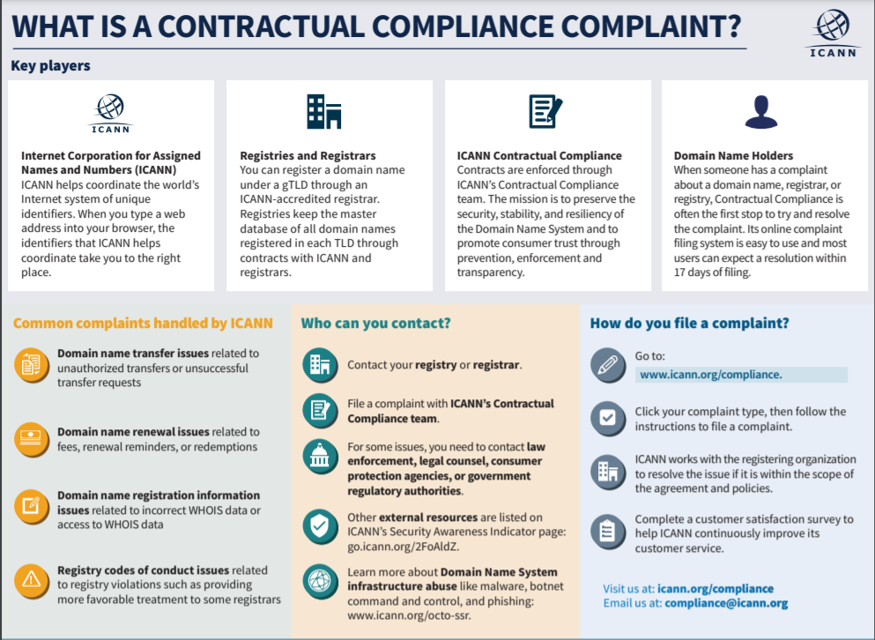

**What Does ICANN Do?**

To reach another person on the Internet you have to type an address into your computer -- a name or a number. That address must be unique so computers know where to find each other. ICANN coordinates these unique identifiers across the world. Without that coordination, we would not have one global Internet.

In more technical terms, the Internet Corporation for Assigned Names and Numbers (ICANN) helps coordinate the Internet Assigned Numbers Authority (IANA) functions, which are key technical services critical to the continued operations of the Internet's underlying address book, the Domain Name System (DNS). The IANA functions include: (1) the coordination of the assignment of technical protocol parameters including the management of the address and routing parameter area (ARPA) top-level domain; (2) the administration of certain responsibilities associated with Internet DNS root zone management such as generic (gTLD) and country code (ccTLD) Top-Level Domains; (3) the allocation of Internet numbering resources; and (4) other services.

**How Does ICANN Work?**

Besides providing technical operations of vital DNS resources, ICANN also defines policies for how the "names and numbers" of the Internet should run. The work moves forward in a style we describe as the "bottom-up, consensus-driven, multi-stakeholder model:"

* **Bottom up.** At ICANN, rather than the Board of Directors solely declaring what topics ICANN will address, members of sub-groups in ICANN can raise issues at the grassroots level. Then, if the issue is worth addressing and falls within ICANN's remit, it can rise through various Advisory Committees and Supporting Organizations until eventually policy recommendations are passed to the Board for a vote.
* **Consensus-driven**. Through its Bylaws, processes, and international meetings, ICANN provides the arena where all advocates can discuss Internet policy issues. Almost anyone can join most of ICANN's volunteer Working Groups, assuring broad representation of the world's perspectives. Hearing all points of view, searching for mutual interests, and working toward consensus take time, but the process resists capture by any single interest– an important consideration when managing a resource as vital as the global Internet.
* **Multistakeholder model**. ICANN's inclusive approach treats the public sector, the private sector, and technical experts as peers. In the ICANN community, you'll find registries, registrars, Internet Service Providers (ISPs), intellectual property advocates, commercial and business interests, non-commercial and non-profit interests, representation from more than 100 governments, and a global array of individual Internet users. All points of view receive consideration on their own merits. ICANN's fundamental belief is that all users of the Internet deserve a say in how it is run.